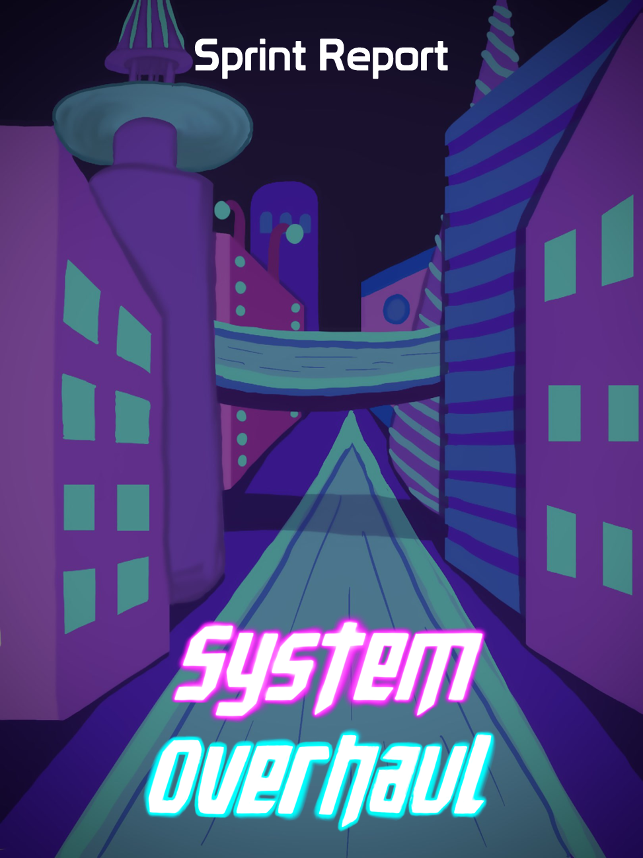





**Table of Contents**

**Previous Week** **2**

Sprint Backlog 2

Review 2

**Next Week** **3**

Sprint Backlog 3

Notes 3

# Previous Week

## Sprint Backlog

| **Tasks** | **Time Needed** | **Responsible** | **Priority** | **Stage** |
| --- | --- | --- | --- | --- |
| Create city | 3 Days | All | High | Completed |
| Fix Bugs | 1 Day | All | High | Completed |
| Friendly NPCs | 1 Day | All | High | Completed |
| Instructions Doc. | ½ Day | All | High | Completed |
| Delivery Report | ½ Day | All | High | Completed |
| Presentation Slides | ½ Day | All | High | Completed |
| Update Computer Graphics Tasks | ½ Day | All | High | Open |
| Update Artificial Intelligence Tasks | ½ Day | All | High | Open |

* 1. Objectives

All of our objectives were completed successfully.

No tasks were planned from the design part.

## Review

All of the tasks were done successfully and were finished in time. The Update Artificial Intelligence Tasks and the Update Computer Graphics Tasks due date have been extended so this tasks will pass to next week

# Next Week

In the “Required for CG & AI” backlog our tasks with higher priority are the following:

| **Tasks** | **Time Estimate** |
| --- | --- |
| Player Hurt Shader | 2 Days |
| Improve Ranged Enemy | 2 Days |
| Improve Melee Enemy | 2 Days |
| Improve the NPCs | 2 Days |

In the “Coding” backlog our tasks with higher priority are the following:

| **Tasks** | **Time Estimate** |
| --- | --- |
| Fix Bugs | ½ Day |
| Pause Menu | ½ Day |
| Main Menu | ½ Day |
| Options Menu | ½ Day |
| GameOver Menu | ½ Day |

In the “3D Models & Animations” backlog the priority of the tasks didn’t change

In the “Docs” backlog our tasks with higher priority are the following:

| **Tasks** | **Time Estimate** |
| --- | --- |
| Update Computer Graphics Tasks | ½ Day |
| Update Artificial Intelligence Tasks | ½ Day |
| GDD | 3 Days |
| Presentation Slides | 1 Day |
| Delivery Report | ½ Day |
| Instructions | ½ Day |
| Spec Sheet | 1 Day |

In the “UI / 2D / Sounds” backlog the priority of the tasks didn’t change

| **Tasks** | **Time Estimate** |
| --- | --- |
| Creation of Stylized Heath Bar | ½ Day |
| Creation of Stylized Abilities Icons | ½ Day |
| Creation of Stylized Buttons | 1⁄2 Day |
| Creation of Menu Background | 1⁄2 Day |
| Find Sounds | 1 1⁄2 Days |

## Sprint Backlog

| **Tasks** | **Time Estimate** | **Responsible** | **Priority** | **Stage** |
| --- | --- | --- | --- | --- |
| Update Computer Graphics Tasks | ½ Day | All | High | Open |
| Update Artificial Intelligence Tasks | ½ Day | All | High | Open |
| Organize Scene | 1 Day | All | High | Open |

## Notes

Next week is the second project presentation.

As we are lacking communication with the designers we aren’t able to know what tasks they are giving priority.